Dana Al Mounayer – s23108503
Lab 2 – Big Data Analytics

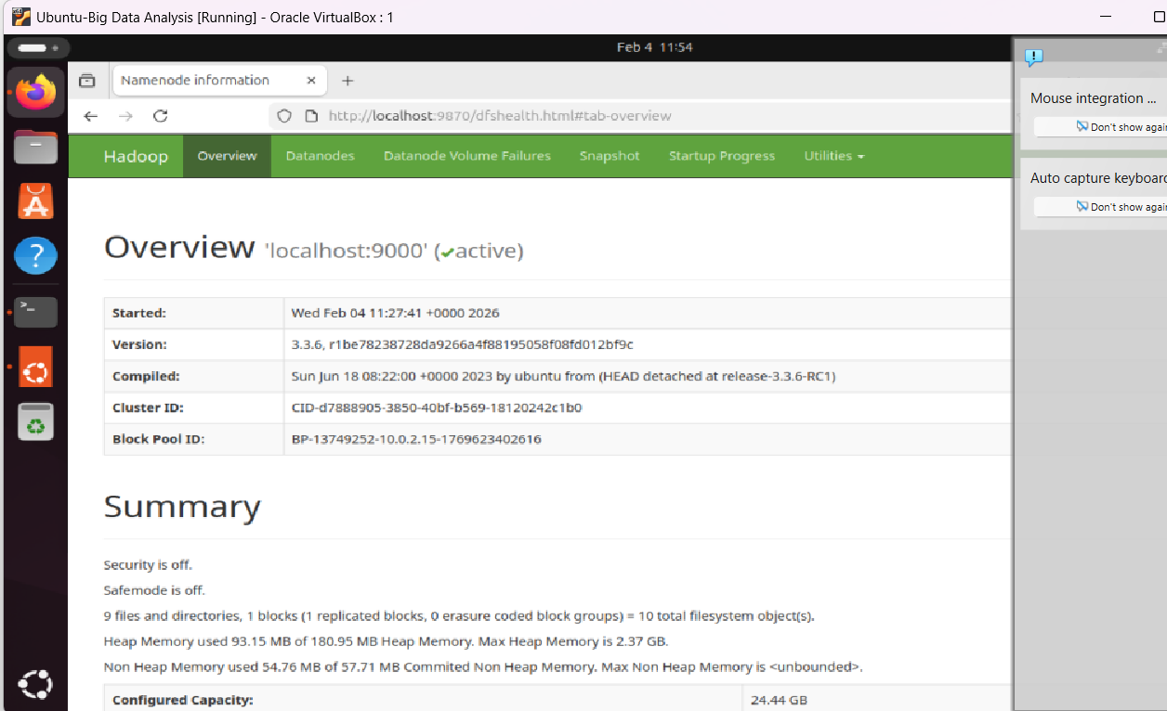
Task 2.1:
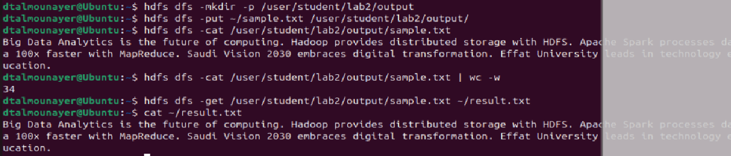
Task 3.2 C:
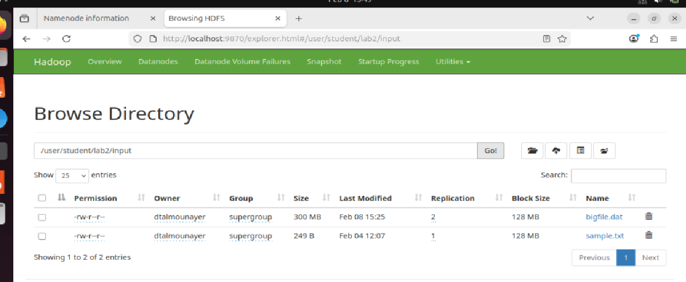
Task 5.2:

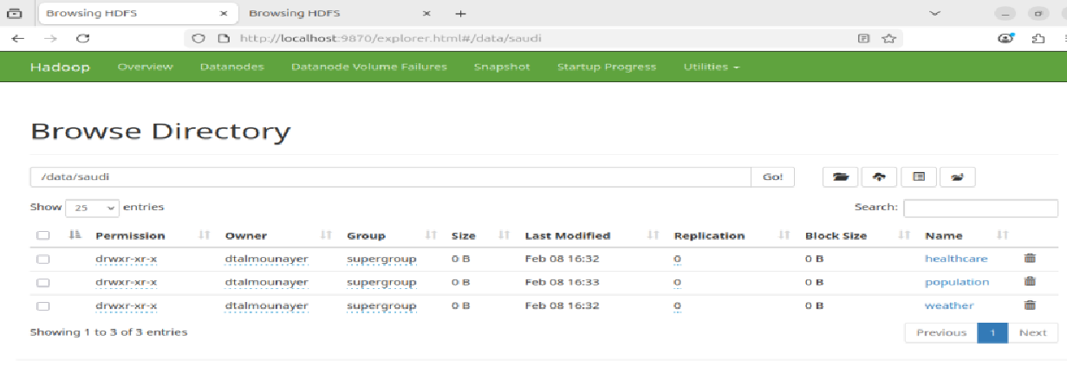
Task 6.4 A:
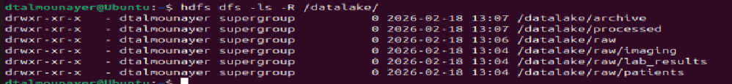
Task 6.4 B:
